ATOC5860 – Application Lab #4
Spectral Analysis of Timeseries
in class March 10 and March 15

ASK IF YOU HAVE QUESTIONS

Notebook #1 – Spectral analysis of hourly surface air temperatures from Fort Collins, Colorado at Christman Field
ATOC5860_applicationlab4_fft_christman.ipynb

LEARNING GOALS:
1) Complete a spectral analysis using two different functions in Python (direct FFT from numpy and using scipy which has more options). Describe the results including an interpretation of the spectral peaks and an assessment of their statistical significance.
2) Contrast applying a Boxcar and a Hanning Window when calculating the power spectra. What are the advantages/disadvantages of these two window types? What are the implications for the resulting power spectra?

DATA and UNDERLYING SCIENCE:
In this notebook, you analyze two years (January 1, 2013 through December 31, 2014) of hourly surface temperature observations from Christman Field in Fort Collins, Colorado. Missing data have been already treated. The data are in .csv format and are called Christman_data_nomissing.csv.

Questions to guide your analysis of Notebook #1:

1) Look at your data. What are the autocorrelation and e-folding time of your data? What spectral peaks do you expect to find in your analysis and how much power do you think they will have?
The temperature lag-1 autocorrelation is 0.99, which is high. The e-folding time, Te, is 100.92 hours. I expect to see spectral peaks at annual and daily intervals that physically represent seasons and day/night cycles. From the high autocorrelation, I also expect a high spectral peak at lower frequencies.

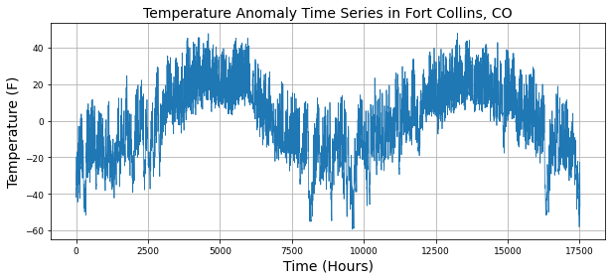

2) Calculate the power spectra using the Numpy method, which assumes a Boxcar window that is the length of your entire dataset. Graph the power spectra, the red noise fit to the data, and the 99% confidence interval. What statistically significant spectral peaks did you find? What do they represent? How did you assess the statistical significance (what is the null hypothesis that you are trying to reject)? Compare back to Barnes and Hartman notes to make sure all of the equations and functions in the notebook are working as you expect them too.
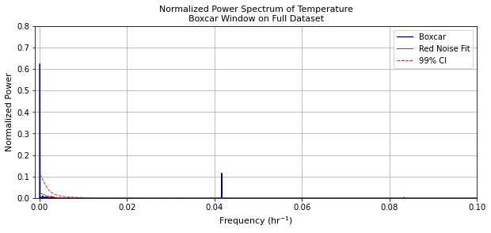
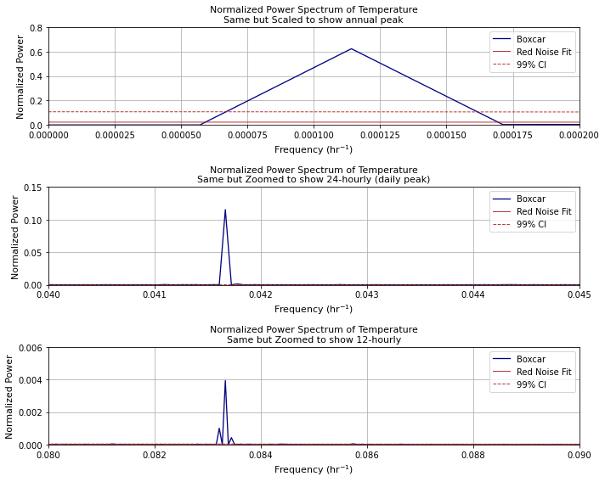
There are statistically significant spectral peaks at the annual, daily, and twelve-hour intervals. The annual cycle has the greatest power and likely represents seasonal cycles. The 24-hour window has power on a similar order of magnitude as the annual peak and likely represents day-night cycles. The 12-hour peak does not make intuitive sense to me but could be associated with processes that occur on two times a day timescale, such as atmospheric tides. Alternatively, this could be a signal from a longer timescale that has been associated to a smaller frequency. The null hypothesis that we are trying to reject is that the peak in the data is red noise. If the peak is larger than the confidence interval, we can reject the null hypothesis that the data is just red noise.

3) Calculate the power spectra using the scipy method. Check that you get the same result as you got using the Numpy method. Next – compare the power spectra obtained using both a Boxcar window and a Hanning window. Assume a window length that is the entire length of the dataset. Do you get the same statistically significant peaks when applying the Hanning window and the Boxcar window? How do they differ? Can you explain why?
Because the data is smoothed, the Hanning window has a broader peak than the Boxcar method.
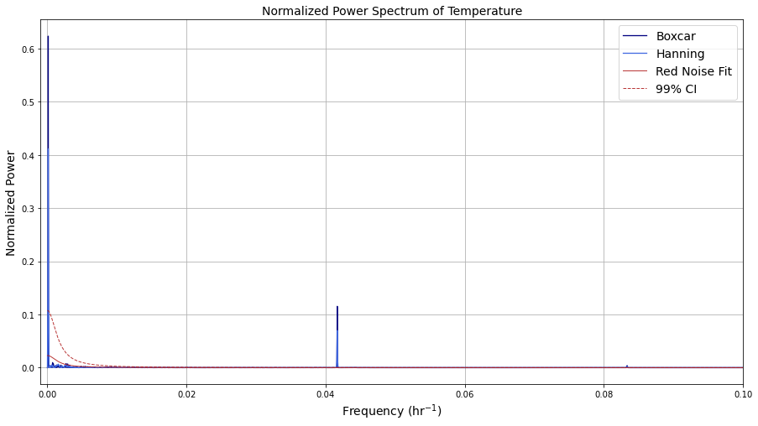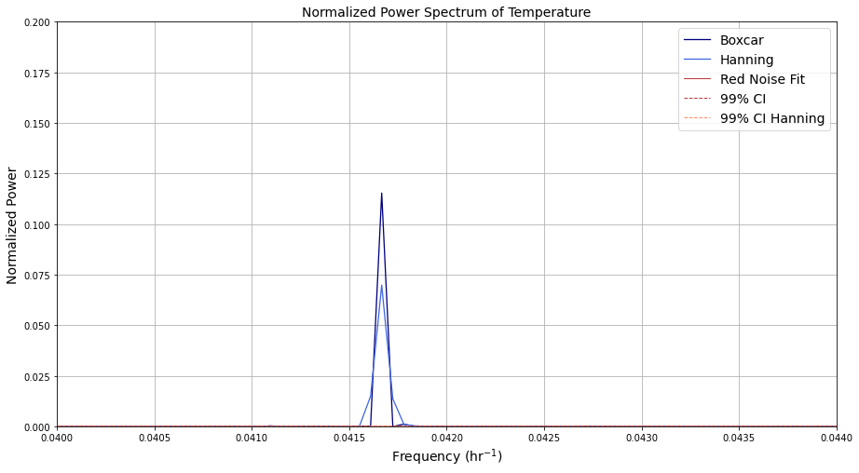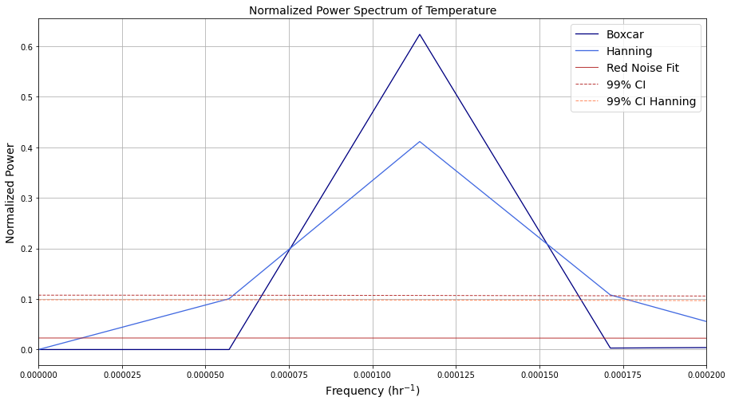

4) If time – take a look at other surface meteorological variables in the dataset. Do you obtain similar spectral peaks?
Wind speed has an autocorrelation of 0.85 (smaller than temperature) and an e-folding time of 6.34 hours, which is much smaller than temperature. The powers for the annual peak, daily peak, and 12-hour peak are all on the same magnitude.
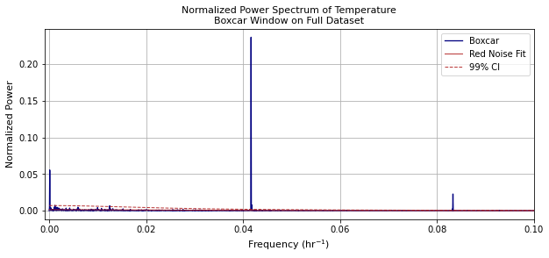
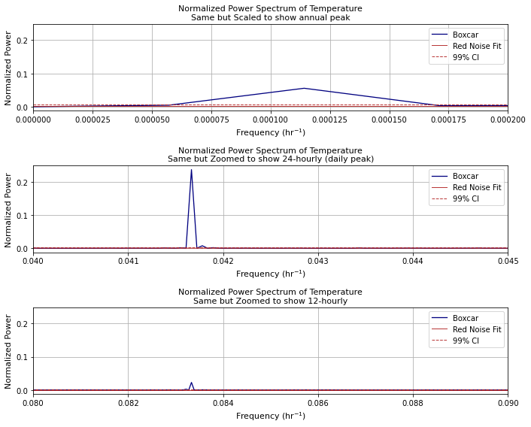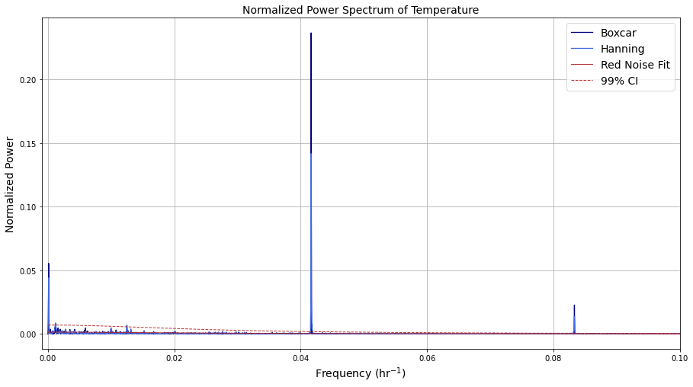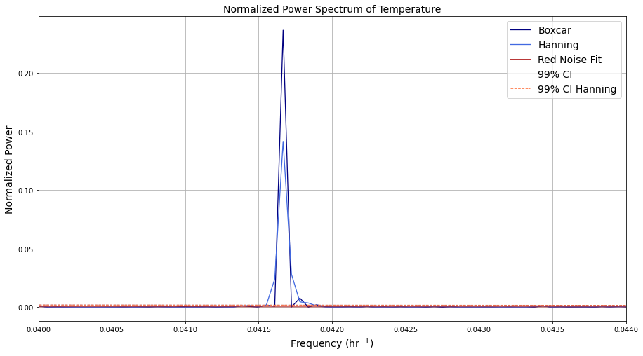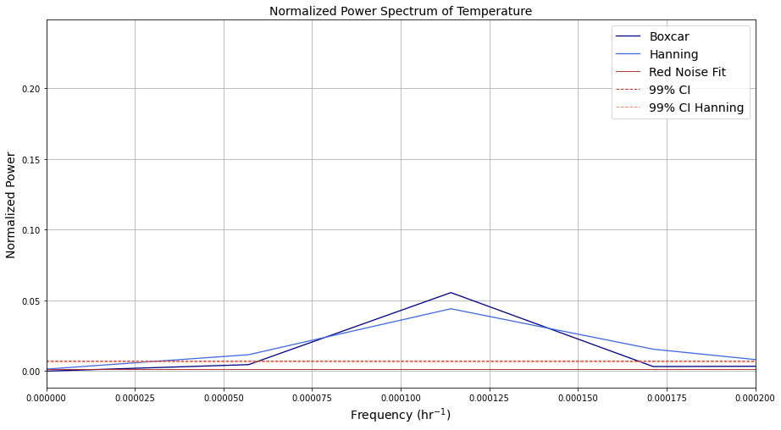

Question: Are you seeing power at 12-hour frequencies when looking at temperature? Maybe it is atmospheric tides? Or is it some kind of spectral ringing artifact? Unsolved mysteries of ATOC7500 Objective Data Analysis…

Notebook #2 – FFT analysis using Dome-C Ice Core Data
ATOC5860_applicationlab4_fft_EPICA.ipynb

LEARNING GOALS:
1) Calculate power spectra of a dataset available on a non-uniform temporal grid. Describe the results including an interpretation of the spectral peaks and an assessment of their statistical significance.
2) Contrast applying a Boxcar and a Hanning Window when calculating the power spectra. What are the advantages/disadvantages of these two window types? What are the implications for the resulting power spectra?
3) Apply a Hanning Window with various window lengths - What are the advantages/disadvantages of changing the window length and the implications for the resulting power spectra in terms of their statistical significance and temporal precision?
4) Apply a Hanning Window with various window lengths and use Welch’s method (Welch’s Overlapping Segment Analysis, WOSA). How does WOSA change the results and why?

DATA and UNDERLYING SCIENCE:
In this notebook, you will perform a power spectral analysis of the temperature record from the Dome-C Ice Core, taken at 75 South and 123 East (Jouzel et al. 2007). The temperature data go back ~800,000 years before present. They are unevenly spaced in time. The data are available on-line here, courtesy of the NOAA Paleoclimatology Program and World Data Center for Paleoclimatology:
ftp://ftp.ncdc.noaa.gov/pub/data/paleo/icecore/antarctica/epica_domec/edc3deuttemp2007.txt More information on the data is available at:
https://www.ncdc.noaa.gov/paleo-search/study/6080

Questions to guide your analysis of Notebook #2:

- Look at your data and pre-process for FFT analysis: Power spectra analysis assumes that input data are on an evenly spaced grid. The Dome-C temperature data are not uniformly sampled in time. Regrid the Dome-C temperature data to a uniform temporal grid in time. Plot the data before and after re-gridding to make sure the re-gridding worked as expected.

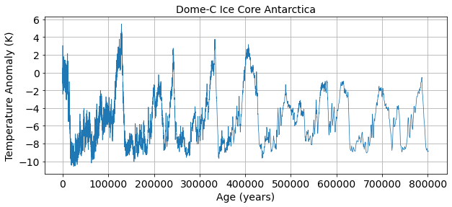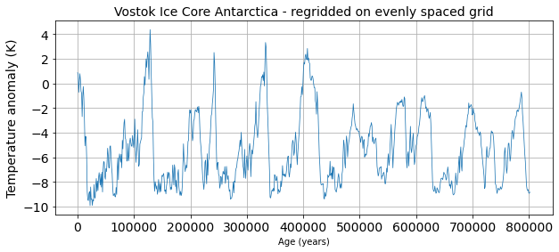
Figure X. a) Raw temperature data and b) re-gridded temperature data.

2) Signal and Noise: What is the autocorrelation and e-folding time of your data? What spectral peaks do you expect to find in your analysis and how much power do you think they will have? Hint: Think back to the Petit 1999 Vostok ice core dataset discussed in class.
The autocorrelation of the data is 0.96 and the e-folding time of the data is 25. I expect to find spectral peaks with high power at lower frequencies because the data has a high autocorrelation.

3) Use Boxcar Window to calculate power spectra: Calculate the power spectra using the Numpy method, which assumes a Boxcar window that is the length of your entire dataset. Graph the power spectrum, the red noise fit to the data, and the 99% confidence interval. What statistically significant spectral peaks did you find? What do they represent?
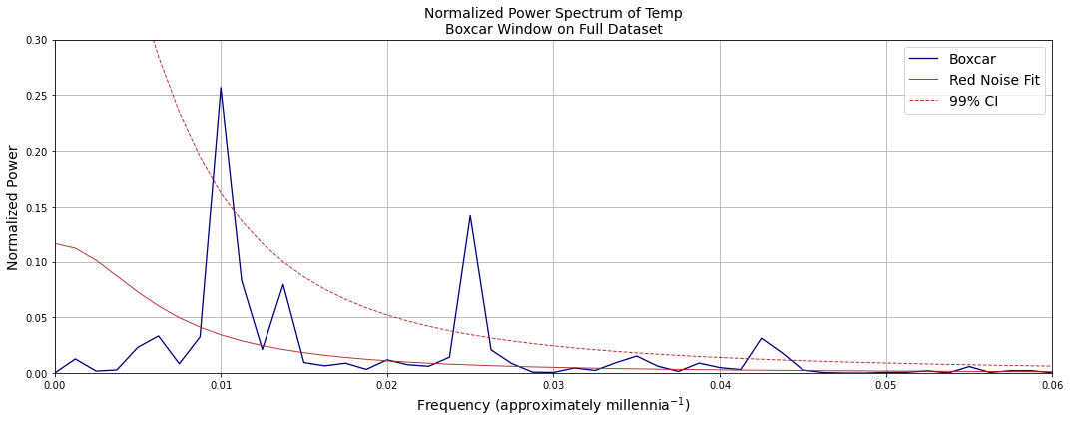
There are four statistically significant spectral peaks. Since there are 1000 years in a millennia, we can divide 1000 years by the decimal at which the peak occurs to get the frequency of the events. The first peak occurs place every 100,00 years and therefore likely represents eccentricity. The second peaks occur every 40,000 years and therefore likely represents obliquity. The third peaks occur approximately every 23,000 years and therefore likely represents precession. This NASA page describes the events and the timescales of events.

4) Compare Boxcar Window vs. Hanning Window: Calculate the power spectra using the SciPy method. Compare the results obtained using a Boxcar window that is the length of your entire dataset to those obtained using a Hanning window that is the length of your entire dataset. Graph the power spectrum, the red noise fit to the data, and the 99% confidence interval. What statistically significant spectral peaks did you find? What do they represent? What are the differences between the results obtained using the Boxcar window and the Hanning window? Is the intuition that you gained by looking at Fort Collins temperatures the same as what you are seeing here with Dome-C temperature records? Why or Why not?
There are four statistically significant peaks that also likely represent the Milankovitch cycles. The Hanning window has shorter, broader peaks because we’ve smoothed the data.

5) Hanning Window with different window lengths: Using the SciPy method, compare the power spectra obtained using Hanning window with different window lengths. Graph the power spectra, the red noise fit to the data, and the 99% confidence interval. Did you find any statistically significant spectral peaks? How does decreasing the window length affect the temporal precision of the spectral peaks and their statistical significance? Did you find the classic tradeoff between 1) high spectral/temporal resolution but low quality statistics, and 2) high quality statistics but low spectral/temporal resolution?
There are three statistically significant spectral peaks., which is one less peak than when using the Boxcar method. Decreasing the window length decreased the temporal precision, decreased the confidence, and increased the degrees of freedom.
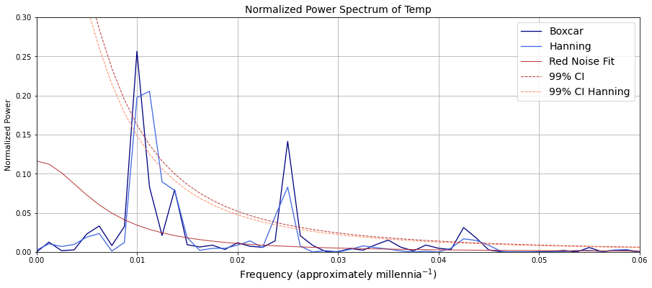
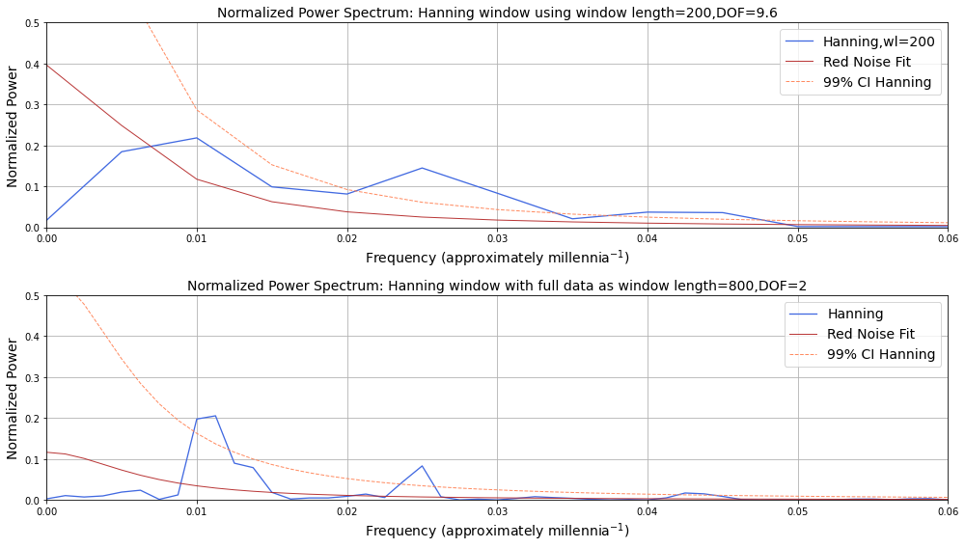

5) Add WOSA (Welch Overlapping Segment Averaging): Having found what you think is a good balance between precision in the identification of the spectral peaks and statistical significance – Try applying WOSA (Welch Overlapping Segment Averaging) in addition to using the Hanning Window with different window lengths. How does this change your results?
Compared to a window of the same size, adding WOSA narrows the peak and increases the confidence.
